FINDING TRAVEL INSURANCE PLAN FOR STUDENTS

Software Requirements Specification

|  |  |  |  |
| --- | --- | --- | --- |
|  | Prepared By | Reviewed By | Approved By |
| Name | Tapabrata Rana | Venkataraman Chandrasekar |  |
| Role | CSD Interns | Batch Trainer |  |

**Table of Contents**

Table of Contents………………………………………………………….….......II

1. Introduction………………………………………………………………….…1

1.1 Intended Audience……………………………………………….......1

1.2 Project Scope…………………………...……………………………1

2. Overall Description…………………………………………….……………….1

2.1 Operating Environment……………………...……………………....1

3. Requirements……………………………………………………………...…….1

3.1Login………………………………………………………………….2

3.1.1Description………………………………………………....2

3.1.2 Functional Requirements……..…………………………...2

**1. Introduction**

**Problem Statement : Find insurance plan for students**

Policybazaar is an Indian [insurance](https://www.bing.com/ck/a?!&&p=41a4e1cae9fe1597JmltdHM9MTcxMzM5ODQwMCZpZ3VpZD0yMDI3MTU2OS0xNjFkLTZmYmYtMzFlNi0wMTZhMTdiMDZlMDEmaW5zaWQ9NTYzMA&ptn=3&ver=2&hsh=3&fclid=20271569-161d-6fbf-31e6-016a17b06e01&u=a1L3NlYXJjaD9xPUluc3VyYW5jZSUyMHdpa2lwZWRpYSZmb3JtPVdJS0lSRQ&ntb=1) [aggregator](https://www.bing.com/ck/a?!&&p=31e6a0b1c07e86b4JmltdHM9MTcxMzM5ODQwMCZpZ3VpZD0yMDI3MTU2OS0xNjFkLTZmYmYtMzFlNi0wMTZhMTdiMDZlMDEmaW5zaWQ9NTYzMQ&ptn=3&ver=2&hsh=3&fclid=20271569-161d-6fbf-31e6-016a17b06e01&u=a1L3NlYXJjaD9xPURhdGElMjBhZ2dyZWdhdGlvbiUyMHdpa2lwZWRpYSZmb3JtPVdJS0lSRQ&ntb=1) and multinational financial technology company , automation is done by satisfying the following test scenarios listed below.

1. Display three lowest international  travel insurance plan with amount and insurance provider company.
2. Group of  2 student people (Age 22,21)
3. For any European country (Suggested Site: policybazaar however you are free to use any other legitimate site)

**1.1 Intended Audience**

Business Unit (BU) SME

Academy coach

Technical Trainer

**1.2 Project Scope**

This document defines at a functional level the business activities that are encompassed by the system and the rules that apply to them. It also encompasses some of the key high- and low-level technical requirements of the system.

It draws heavily on both the proposed Framework and Business Rules and the Technical Architecture documents. The scope of the detailed analysis project phase specifies that this document will include.

· Classification of requirements according to their functional areas.

· A description of each process in the system, including their inputs, outputs, and data transformation rules.

**2. Overall Description**

**2.1 Operating Environment**

Windows operating system

Web application

**3. Requirements**

This part of the requirements document serves to present the "PolicyBazaar for **finding insurance plan for students** " of the application and also, we need to extract the travel insurance plan , health insurance , car insurance.

**3.1.1 Functional Requirements**

**3.1.1.1 Req0001**

**Find travel insurance plan for students**

User navigates to the travel insurance page

User enters destination details

User enters trip date details

User enters travellers details

User enters medical history details

User enters contact details

User gets the student insurance plan details

User navigates to policy bazaar homepage

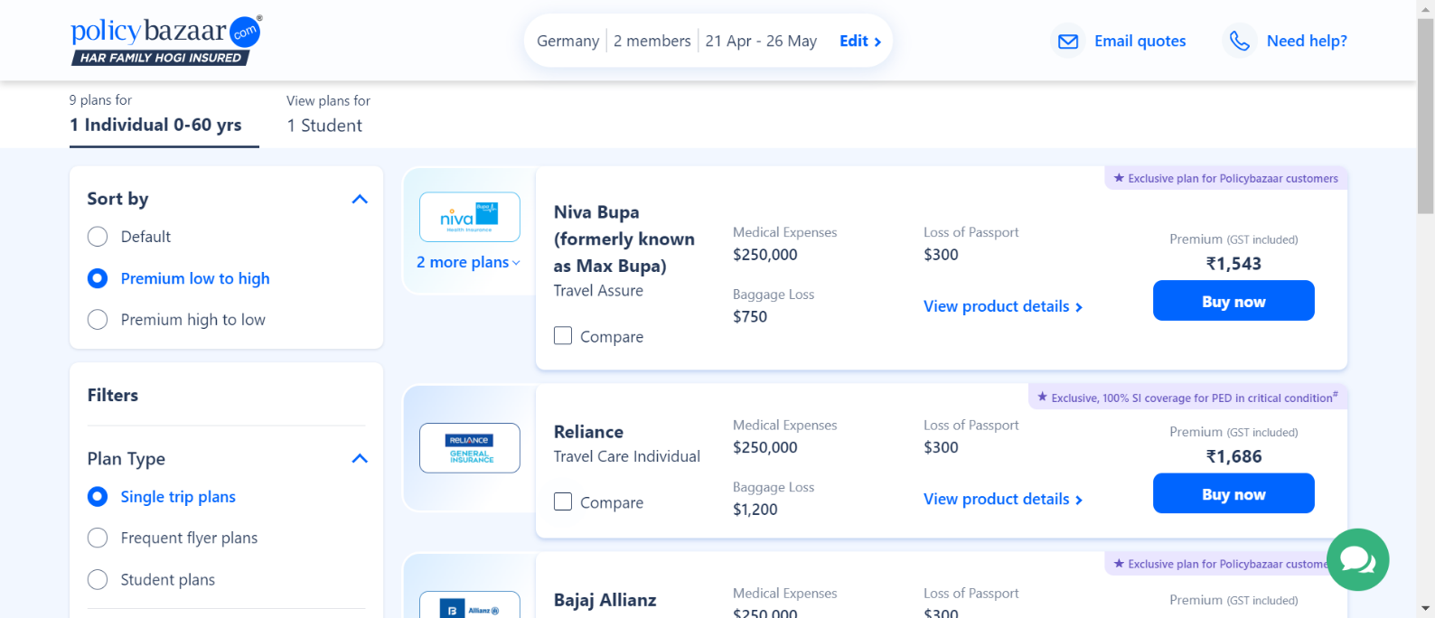

**3.1.1.2 Req0002**

**Getting a Car Insurance quote**

User navigates to the car insurance page

User selects city and rto

User selects car details

User fills incorrect user details and gets error message

User navigates to the policy bazaar homepage

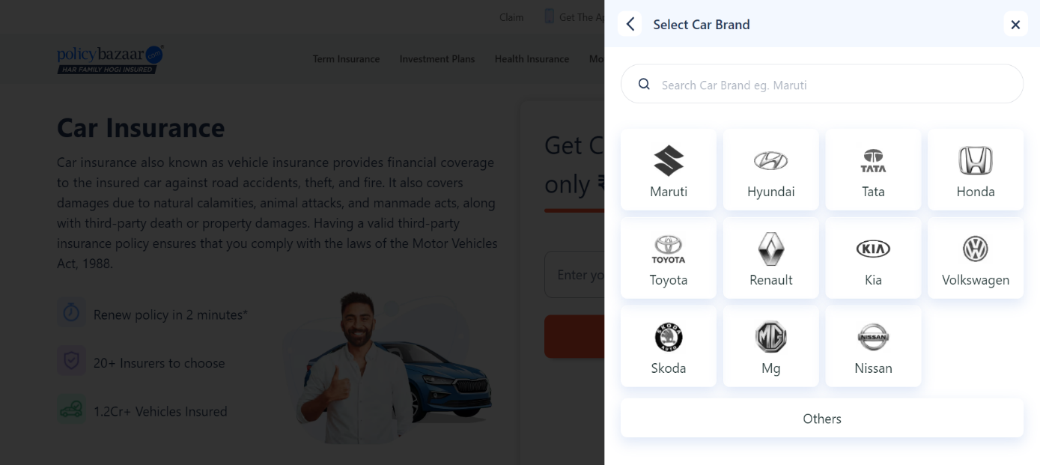

**3.1.2.3 Req0003**

**Retrieving all Health Insurance menu items**

User clicks on health insurance menu

User displays all health insurance plans

